**ABUNDANCE, DISTRIBUTION, AND DISSUASION EFFORTS OF CASPIAN TERNS (*Hydroprogne caspia*) and DOUBLE CRESTED CORMORANTS (*Phalacrocorax auritus*) ON RICE, MILLER, AND PILLAR ISLANDS OF THE COLUMBIA RIVER: 2021 SEASON SUMMARY REPORT**

Fisheries Field Unit

U.S. Army Corps of Engineers, Bonneville Lock and Dam, Cascade Locks, OR 97014

Christine M. Brandtner and Kyle S. Tidwell

Correspondence: [Kyle.S.Tidwell@usace.army.mil](mailto:Kyle.S.Tidwell@usace.army.mil)

**SUMMARY**

This report documents compliance with Term and condition 1.k. of the 11 July 2012 Biological Opinion issued by NMFS for the Columbia River Navigation Channel Operations and Maintenance, Mouth of the Columbia River to Bonneville Dam, Oregon and Washington. Term and condition 1.k. requires the U.S. Army Corps of Engineers to monitor dredge material placement sites during the nesting season and discourage any avian predators that are found attempting to nest near the dredged material placement site consistent with the Migratory Bird Treaty Act. The upland placement sites of concern are located at Rice Island, Miller Sands spit and Pillar Rock Island. No Caspian Terns (*Hydroprogne caspia*) or Double Crested Cormorants (*Phalacrocorax auritus*) nested within these upland placement sites in 2021.

To satisfy the requirements of the Biological Opinion, the Fisheries Field Unit conducted monitoring and dissuasion efforts to document and dissuade piscivorous water bird species at these sites between 2 March and 9 August 2021. The objective of the work is to dissuade birds from the primary island of nesting interest, Rice Island. Here, we report that the dissuasion efforts were successful this season: One Caspian Tern egg was collected in accordance with the dissuasion and take efforts and all other nesting attempts were successfully dissuaded. The authorization and operation of the autonomous green laser was utilized in 2021 to deter CATE from roosting in the bowl of Rice Island. The abundance and distribution of Double-Crested Cormorants, another colonial piscivorous water bird species found to significantly impact salmonid stocks, was also monitored and was observed within the historic observation estimates. Low numbers were recorded daily at the water’s edge of Rice and Pillar Islands. No cormorant nesting was documented on any of the dredge material placement islands.

**Table of Contents**

List of Figures.......………………………………………………………………………………...3

List of Tables.………………………………………………………………………………….….3

Background…………………………………………………………………………....……….….4

Methods….……………………………………………………………………...…………….…..5

Results: Surveys and Dissuasion…………………………………………………….……………8

Discussion………………………………………………………………………...……………...10

Acknowledgements……………………………………………………………….…………...…11 Literature Cited………………………………………………………………………….……….11

**List of Figures**

Figure 1. Aerial image of Rice, Miller, and Pillar Islands…….………………………………….6

Figure 2. Aerial image of the western end of Rice Island………………………………………...7

Figure 3. USACE biologist connecting the autonomous green laser on Rice Island……….……8

**List of Tables**

Table 1. Abundance monitoring data for Caspian Tern abundance on Rice, Miller, and Pillar Islands in the Columbia River Estuary between 2 March and 9 August 2021.…………………...9

Table 2. Abundance monitoring data for Caspian Tern nest scrapes on Rice, Miller, and Pillar Islands in the Columbia River Estuary between 2 March and 9 August 2021.……………………………………………………………………………………………...10

Table 3. DCCO point counts on East Rice Pilings……………………………………………………………...…………………………….13

Table 4. DCCO point counts on N. Pillar Piles…………………………………...………………………………………………………….14

Supplementary Table 1. Raw data for Rice Island Caspian Tern monitoring during the 2021 season. Dates not presented were not sampled………….……………………………………….15

**BACKGROUND**

Long-term evaluation of Caspian Terns (CATE; *Hydroprogne caspia*, formerly *Sterna caspia*) and Double-Crested Cormorants (DCCO; *Phalacrocorax auritus*) in the Columbia River estuary has revealed that strong concentrations of the birds can lead to significant impacts to some endangered salmonid stocks (Evans et al. 2012, 2019, Adkins et al. 2014). In response to the increased presence and abundance of these bird species in the Columbia estuary, NOAA fisheries issued a biological opinion in 1999 requiring the U.S. Army Corps of Engineers (USACE) to dissuade colonial water birds (i.e. CATE and DCCO) from nesting on USACE managed and operated lands in the estuary. These avian associated requirements of the 1999 Biological Opinion (BiOp) have been reissued in every BiOp since and have led to complex management efforts to balance the impacts of avian predators on ESA listed salmonids while preserving the integrity of the avian populations in the Pacific Flyway (NOAA 1999, 2005, 2012).

Formed in 1984, the primary colony for CATE had historically been Rice Island, a state-owned island used by the Corps for placement of dredged material. In 2000 the CATE colony on Rice Island was successfully moved to East Sand Island (ESI) in the lower estuary near the mouth of the Columbia River. The dissuasion and hazing methods developed to move the colony from Rice Island to ESI have since been employed to continually deter re-colonization of Rice Island and the nearby deposition sites of Pillar Rock and Miller Sands Islands (NOAA 2005, Figure 1). Continued monitoring and dissuasion is required to ensure that CATE and DCCO do not attempt to recolonize these dredge material placement sites.

Specifically, term and condition 1.k. of the 11 July 2012 Biological Opinion issued by NMFS for the Columbia River Navigation Channel Operations and Maintenance, Mouth of the Columbia River to Bonneville Dam, Oregon and Washington requires the Corps to monitor upland [dredged material placement] sites during the nesting season and discourage any avian predators that are found nesting at an upland [dredged material placement] site, consistent with the Migratory Bird Treaty Act. To comply with this condition in 2021, the USACE Fisheries Field Unit (FFU) operationalized a monitoring and dissuasion effort on Rice, Miller, and Pillar Islands, funded by the Columbia & Lower Willamette Rivers federal navigation channel project. The objective of the effort was to deter CATE and DCCO interest in these sites and ensure no CATE or DCCO successfully reproduced on these islands. Using the methods developed by Real Time Research™ and with personal communications and support from independent contractors, the OSU-USGS avian research cooperative unit, and various USACE personnel, the FFU deployed dissuasion materials on Rice Island and recorded CATE abundance and breeding activity on Rice, Miller, and Pillar Island. This report documents the monitoring and dissuasion efforts from 2 March through 9 August 2021.

**METHODS**

**Surveys and Dissuasion**

We deployed passive dissuasion materials (i.e. ropes, stakes, and flagging) on Rice Island during the 2021 season to deter birds when observers were not present. Active hazing walks and bird monitoring began on 13 April 2021. Miller and Pillar Islands were initially assessed everyday Rice Island was monitored. However, low CATE presence justified a reduced monitoring effort for these upstream islands exclusively when CATE were observed on Rice Island (Table 1).

All avian abundance data were collected by FFU biologists using 10 x 42 field glasses from boat and ground-based observation surveys. To enhance inter-count reliability, boat-based surveys of Miller and Pillar Islands were conducted using the same transects in the water and the same observation points established before seasons’ start. If CATE were documented on Miller or Pillar Islands observations crews were trained to make landfall and sample the site where birds were present to look for nesting activity. Rice Island observations were a combination of boat-based followed by on-the-ground sampling.

Nest fill data were collected by enumerating the number of nests encountered on the sampling transects. All nests were filled with sand after enumeration to avoid double counting. To further avoid double counting, observers stayed within the designated boundaries of the transects and therein reduced the number of boot prints on the island that can change with wind to resemble a nest scrape.

All data were recorded on handheld devices using the ArcGIS Collector Application® and is reported here as the mean estimates and associated standard deviation for all results of the 2021 data.

To enhance passive dissuasion efforts, we submitted a proposal for an autonomous green laser (AVIX laser®, Bird Control Group, Wilsonville, OR. 97070) to be situated over the west end berm on Rice Island to deter CATE. Our proposal was granted by the US Fish and Wildlife Service on 18 May 2021 and the green laser was installed the following day, 19 May 2021. The intention of the autonomous green laser machine was to dissuade CATE from the historic roosting area on the west end of Rice Island (Figure 3) and minimize human presence on the island while reducing the use of plastic materials. Prior to turning the laser on, we observed for Streaked Horned Lark (*Eremophila alpestris strigata*) near the laser site, and none were observed. The green laser was turned on in the evening of 2 June 2021 for a 12-hour period – 30 min before sundown to 30 minutes after sunup when boat-based traffic in the river was at its lowest. A USACE biologist stayed on the island on 2 June and monitored the laser during the time of operation to ensure compliance with requirements.

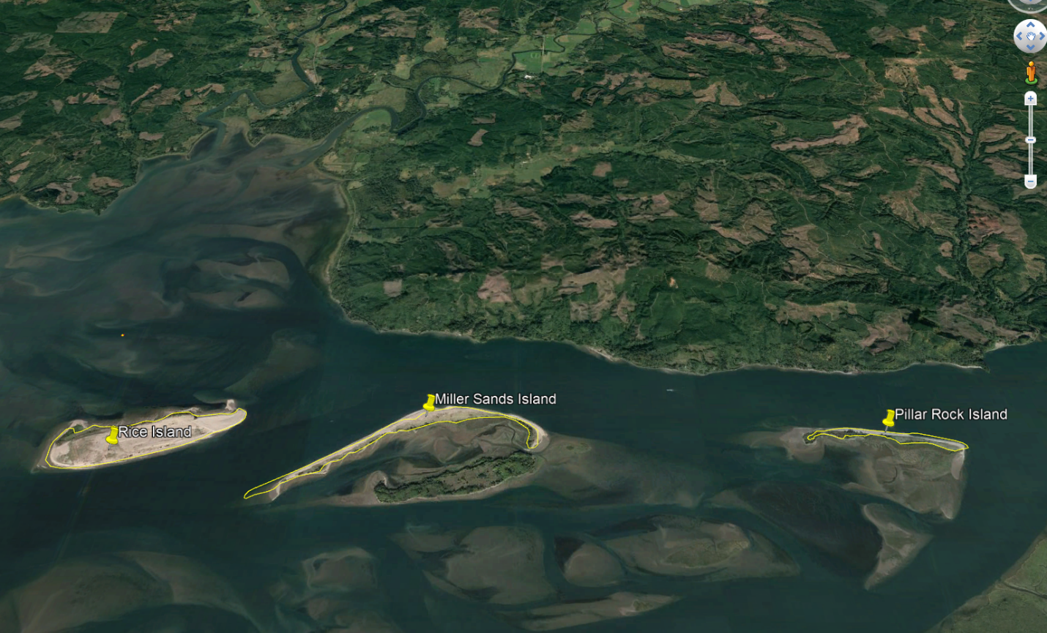

Figure 1. Aerial image of Rice, Miller, and Pillar Islands (left to right).

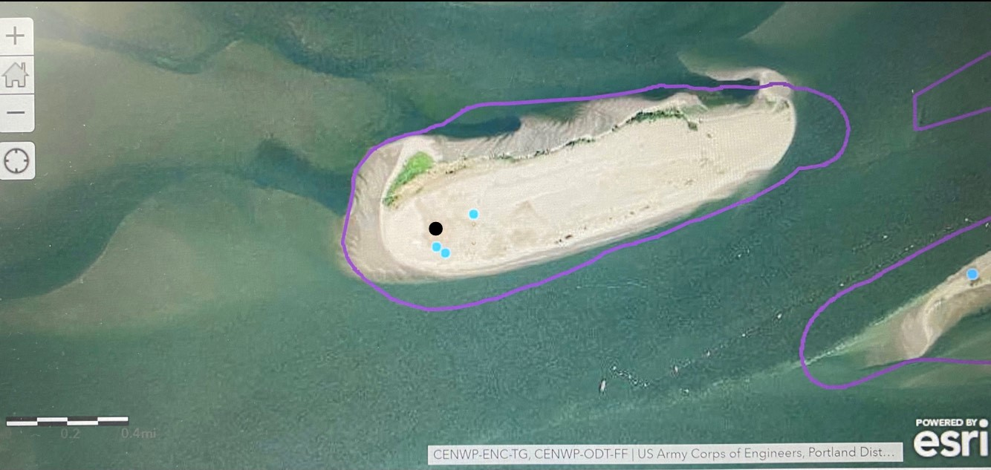Figure 2. Aerial image of the western end of Rice Island. Blue dots indicate where CATE eggs or scrapes were recorded and dissuasion was installed. The black dot indicates the location of the green laser.

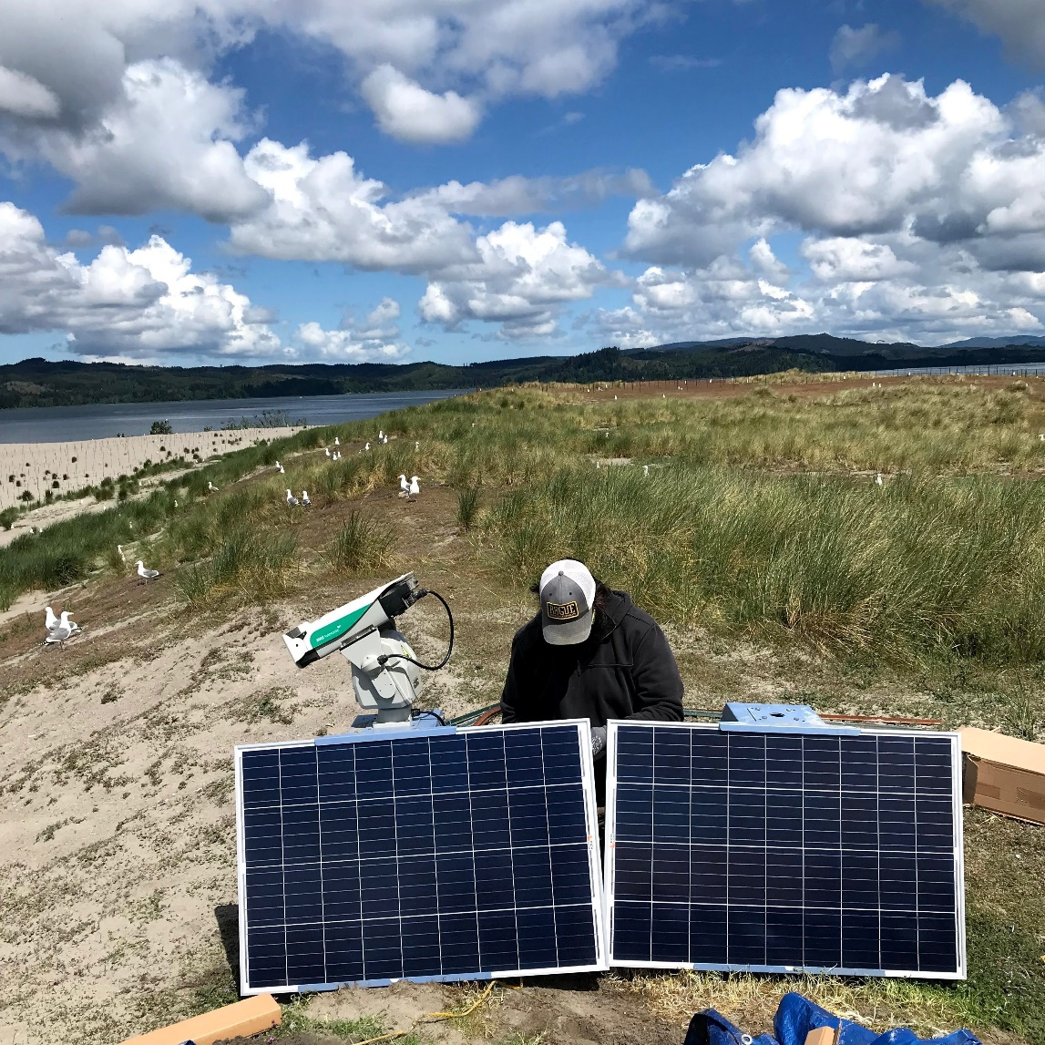

Figure 3. USACE biologist connecting the autonomous green laser on Rice Island 19 May 2021.

**RESULTS**

**Abundance and Distribution:**

A total of 24 days of monitoring and dissuasion were conducted this season on Rice Island. On 13 of these days, sampling was completed on Miller and Pillar Islands. CATE were observed for three days on Miller Island and two days on Pillar Rock Island (Table 1). Rice Island was surveyed every day of the 24 sample days. The average daily abundance estimate of CATE on Rice Island was 294.9 ± S.D. 408.2 birds and an average scrape estimate of 85.3 ± S.D. 112.6 scrapes per day (Table 1). One CATE egg was observed on Rice Island on 12 May and was collected pursuant to the dissuasion and egg take permit granted by the USF&W. In response to a one-day high scrape count of 1,355 scrapes on 27 April, 0.5 acres of dissuasion was deployed (Table 1, Figure 2).

We report the green laser effectively moved CATE off the west bowl of Rice Island. However, the CATE unexpectedly relocated to the center of the island. We actively hazed the CATE with regard and attention to nearby Streaked Horned Lark nesting locations, and successfully deterred CATE from the center of the island without disturbing the Larks. Following the one day deployment of the laser, CATE abundance dropped on the island and no more nesting attempts were observed. In adhering to our USF&W permit requirements, the green laser did not interact with resident gulls and didn’t cross into the nearby Streaked Horned Lark habitat. Gulls moved away from the sweeping laser beam and no Larks were observed in the west bowl area of the island.

Biologists conducted point counts for DCCO from Rice Island to Pillar Island. 17 days of sampling occurred for the East Rice Pilings and Rice Pilings and we report that by 15 June 2021 no DCCO were seen on the North Pillar Piles (Table 3). Of the days observed there were an average of 134.6 ± S.D. 146.8 DCCO on the northern Pilings of Pillar and 613.1 ± S.D. 507.2 DCCO on the eastern pilings next to Rice (Table 2, Table 3). No DCCO were seen in the upland portions of any of these islands. All DCCO observations were below the high-water mark.

For contrast to previous reports of this work on Rice Island, the raw observation data are listed in Supplementary Table 1.

Table 1. Abundance monitoring data for Caspian Tern abundance on Rice, Miller, and Pillar Islands in the Columbia River Estuary between 2 March and 9 August 2021.

|  |  |  |  |  |
| --- | --- | --- | --- | --- |
|  |  | **CATE ABUNDANCE** | | |
| Site | *n* days monitored | $\overline{x}$ ± S.D. | Range | $$n days=0$$ |
| Rice Island | 24 | 294.9 ± 408.2 | 0 - 1355 | 6 |
| Miller Island | 13 | 44.6 ± 96.0 | 0 - 300 | 10 |
| Pillar Rocks | 13 | 13.2 ± 40.3 | 0 - 140 | 10 |

Table 2. Abundance monitoring data for Caspian Tern nest scrapes on Rice, Miller, and Pillar Islands in the Columbia River Estuary between 2 March and 9 August 2021. Note that Millar and Pillar Islands are not monitored for scrapes unless Caspian Terns are observed in the upland areas.

|  |  |  |  |  |
| --- | --- | --- | --- | --- |
|  |  | **CATE SCRAPE** | | |
| Site | *n* days monitored | $\overline{x}$ ± S.D. | Range | $$n days=0$$ |
| Rice Island | 24 | 85.3 ± 112.6 | 0 - 390 | 6 |
| Miller Island | 13 | 0 | N/A | N/A |
| Pillar Rocks | 13 | 0 | N/A | N/A |

**DISCUSSION**

The management objective of CATE and DCCO dissuasion from Rice, Miller, and Pillar Islands was successful this year. CATE abundance and nesting attempts on Rice Island were suppressed by dissuasion efforts and the installation of the green laser. We report that the green laser did deter CATE from roosting in the western bowl of Rice Island (Figure 2). The distribution of CATE on Rice Island was different from previous years wherein, in 2020 birds preferred the center of the dredge material placement site. In 2021, CATE gathered on the southwestern rim of the island. Moreover, no DCCO were observed above the shoreline in the study area. Biologists regularly walked or drove an ATV around the entire western rim on Rice in order to observe CATE and DCCO on the north side of Rice. In 2021 we deployed less than 0.5 acres of dissuasion which was less than the 4.1 acres of passive dissuasion deployed in 2020.

CATE abundance and nesting attempts declined on Rice Island after the installation of the autonomous green laser and persistent adaptive management. The three-year trend would suggest that CATE interest in nesting on Rice Island is diminishing however, the persistent early season interest in Rice Island in 2021 suggests that CATE re-establishment of the colony may occur if dissuasion and monitoring efforts are not consistently applied. Therefore in 2022, the USACE plans to submit approval for use of the autonomous green laser again to the US Fish and Wildlife Service. It is too soon to know if the green laser will have a continual impact on the determent of attempted CATE nesting on Rice Island, but we report that the use of the laser in 2021 didn’t have any negative implications to Rice Island wildlife. The results from this season are encouraging but need further evaluation and this will be possible by installing the green laser earlier in 2022 pending authorization.

The objective of the USACE was to ensure no DCCO attempted to nest within the dredged material placement sites on Rice, Miller, or Pillar Islands. The USACE met the management objectives for DCCO in the Rice, Miller, Pillar management area because no DCCO or DCCO nests were observed within the placement sites (Table 2, Table 3). All observations of DCCO near these islands were made outside of dredge material placement sites. As such, no DCCO nests were observed on placements sites. The majority of the DCCO observed near the three islands of interest were on the eastern pilings next to Rice Island and no nesting attempts were documented. DCCO abundance and distribution appear to be similar to what has been discussed previously with the Avian Management Team.

**ACKNOWLEDGEMENTS**

We recognize the support of the Real Time Research Crew (Ken Collis, Allen Evens, and James Tennyson) and the Civilian Air Patrol Crew (Jonathan Ritchie). We also recognize the diligent monitoring efforts of FFU research staff that provided this data set. Thank you to: Deven McCanna, Darren Gallion, Steven Sachs, Bjorn van der Leeuw, and Robert Wertheimer.

**literature cited**

Adkins, J.Y., D.E. Lyons, P.J. Loschl, D.D. Roby, K. Collis, A.F. Evans, and N.J. Hostetter. 2014. Demographics Of Piscivorous Colonial Waterbirds And Management Implications For ESA-Listed Salmonids On The Columbia Plateau. Northwest Science 88:344-359

Evans, A.F., N.J. Hostetter, D.D. Roby, K. Collis, D.E. Lyons, B.P. Sandford, And R.D. Ledgerwood. 2012. System-Wide Evaluation Of Avian Predation On Juvenile Salmonids From The Columbia River Based On Recoveries Of Passive Integrated Transponder Tags. Transactions of The American Fisheries Society 141:975-989.

Harper, J. and K. Collis. 2018. 2018 hazing and Dissuasion of Caspian Terns in the Lower Columbia Estuary: Season End Summary Report. 10 Pg.

NOAA Fisheries. 1999. Endangered Species Act – Section 7 Consultation Biological Opinion, Columbia River Navigation Channel Operation and Maintenance Dredging. NWR-1999-1150. Northwest Region. Seattle, Washington. September 15, 1999.

NOAA Fisheries. 2005. Endangered Species Act – Section 7 consultation biological opinion and conference opinion & Magnuson-Stevens Act Essential Fish Habitat Consultation, reinitiation of Columbia River Federal Navigation Channel improvements project. NMFS No. 2004/01612. Northwest Region. Seattle, Washington. February 16, 2005.

NOAA Fisheries. 2012. Reinitiation of Endangered Species Act Section 7 Formal Consultation and Magnuson-Stevens Fishery Conservation and Management Act Essential Fish Habitat Consultation for the Columbia River Navigation Channel Operations and Maintenance, Mouth of the Columbia River to Bonneville Dam, Oregon and Washington (HUCs 1708000605, 1708000307, 1708000108). NMFS No. 2011/02095. Northwest Region. Seattle, Washington. July 11, 2012.

Table 3. DCCO point counts on East Rice Pilings.

|  |  |
| --- | --- |
| Date | Point Count |
| 22-Apr | 8 |
| 27-Apr | 130 |
| 29-Apr | 355 |
| 4-May | 310 |
| 12-May | 840 |
| 19-May | 680 |
| 25-May | 587 |
| 1-Jun | 310 |
| 7-Jun | 120 |
| 9-Jun | 50 |
| 13-Jul | 0 |
| 15-Jun | 142 |
| 16-Jun | 1220 |
| 22-Jun | 1167 |
| 29-Jun | 145 |
| 13-Jul | 645 |
| 9-Aug | 900 |

Table 4. DCCO point counts on N. Pillar Piles

|  |  |
| --- | --- |
| Date | Point Count |
| 27-Apr | 27 |
| 29-Apr | 90 |
| 4-May | 350 |
| 12-May | 278 |
| 19-May | 318 |
| 25-May | 13 |
| 1-Jun | 0 |
| 7-Jun | 1 |
| 15-Jun | 0 |
| 22-Jun | 0 |

Supplementary Table 1. Raw data for Rice Island Caspian Tern monitoring during the 2021 season. Dates not presented were not sampled.

|  |  |  |  |
| --- | --- | --- | --- |
| Date 2021 | # CATE Eggs | # CATE Scrapes | # CATE |
|
|
| 2-Mar | - | - | 0 |
| 22-Apr | - | 9 | 310 |
| 27-Apr | - | 114 | 1355 |
| 29-Apr | - | 120 | 260 |
| 4-May | - | 135 | 63 |
| 12-May | 1 | 260 | 220 |
| 19-May | - | - | 0 |
| 20-May | 0 | 0 | 0 |
| 25-May | 0 | 390 | 183 |
| 1-Jun | - | 71 | - |
| 2-Jun | - | 87 | 0 |
| 7-Jun | - | 94 | 133 |
| 15-Jun | - | 0 | 20 |
| 22-Jun | - | 0 | 110 |
| 29-Jun | - | 0 | 0 |
| 13-Jul | - | 0 | 0 |
| 9-Aug | 0 | 0 | - |